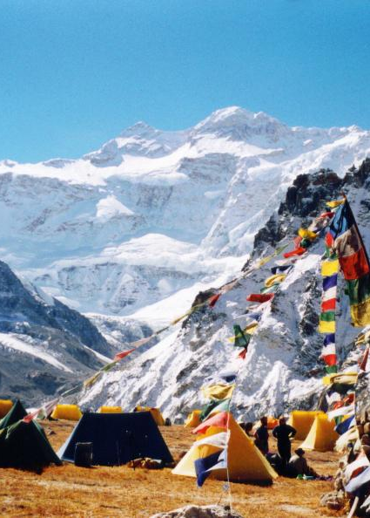  is a new,  easy to read,  pocket sized guide  on how to stay healthy at altitude.  Are you planning a family holiday, adventure travel or a mountaineering expedition?    Download a copy free-of-charge from www.medex.org.uk  Find out about altitude illness, how to acclimatise  and what to do if you become unwell. |  | is a new,  easy to read,  pocket sized guide  on how to stay healthy at altitude.  Are you planning a family holiday, adventure travel or a mountaineering expedition?  Download a copy free-of-charge from www.medex.org.uk  Find out about altitude illness, how to acclimatise  and what to do if you become unwell.
is a new,  easy to read,  pocket sized guide  on how to stay healthy at altitude.  Are you planning a family holiday, adventure travel or a mountaineering expedition?  Download a copy free-of-charge from www.medex.org.uk  Find out about altitude illness, how to acclimatise  and what to do if you become unwell. |  | is a new,  easy to read,  pocket sized guide  on how to stay healthy at altitude.  Are you planning a family holiday, adventure travel or a mountaineering expedition?  Download a copy free-of-charge from www.medex.org.uk  Find out about altitude illness, how to acclimatise  and what to do if you become unwell.
is a new,  easy to read,  pocket sized guide  on how to stay healthy at altitude.  Are you planning a family holiday, adventure travel or a mountaineering expedition?  Download a copy free-of-charge from www.medex.org.uk  Find out about altitude illness, how to acclimatise  and what to do if you become unwell. |  | is a new,  easy to read,  pocket sized guide  on how to stay healthy at altitude.  Are you planning a family holiday, adventure travel or a mountaineering expedition?  Download a copy free-of-charge from www.medex.org.uk  Find out about altitude illness, how to acclimatise  and what to do if you become unwell.
is a new,  easy to read,  pocket sized guide  on how to stay healthy at altitude.  Are you planning a family holiday, adventure travel or a mountaineering expedition?  Download a copy free-of-charg from www.medex.org.uk  Find out about altitude illness, how to acclimatise  and what to do if you become unwell. |  | is a new,  easy to read,  pocket sized guide  on how to stay healthy at altitude.  Are you planning a family holiday, adventure travel or a mountaineering expedition?  Download a copy free-of-charge from www.medex.org.uk  Find out about altitude illness, how to acclimatise  and what to do if you become unwell.
is a new,  easy to read,  pocket sized guide  on how to stay healthy at altitude.  Are you planning a family holiday, adventure travel or a mountaineering expedition?  Download a copy free-of-charge from www.medex.org.uk  Find out about altitude illness, how to acclimatise  and what to do if you become unwell. |  | is a new,  easy to read,  pocket sized guide  on how to stay healthy at altitude.  Are you planning a family holiday, adventure travel or a mountaineering expedition?  Download a copy free-of-charge from www.medex.org.uk  Find out about altitude illness, how to acclimatise  and what to do if you become unwell.

